[Vinaphone Postpaid Rating Solution of Comverse ]

[High level analysis]

[Technical Specs]

Copyright and Trademarks

This documentation contains proprietary and confidential material of Comverse, Inc. and its affiliates and suppliers. Any unauthorized reproduction, use, or disclosure of this material, or any part thereof, is strictly prohibited.

This documentation is solely for the use of Comverse employees and authorized Comverse customers. The material furnished in this documentation is believed to be accurate and reliable. However, Comverse assumes no responsibility for the use of this material. Comverse reserves the right to make changes to the material at any time and without notice.

This documentation is intended for information and operational purposes only. No part of this documentation shall constitute any contractual commitment whatsoever by Comverse.

©2004-2010 Comverse, Inc. All rights reserved.

Comverse, its logo, the spark design, Kenan, and Netcentrex are registered trademarks of Comverse Technology, Inc. or its subsidiaries in the United States and may also be registered in other countries.

Other denoted product names of Comverse or other companies may be trademarks or registered trademarks of Comverse, Inc. or its subsidiaries, or their respective owners.

Corporate Headquarters

200 Quannapowitt Parkway

Wakefield, MA 01880 USA

Tel: (781) 246-9000

Fax: (781) 224-8143

[www.comverse.com](http://www.comverse.com)

Document Name:

Revision History

| Rev | Date | Author | Description | Approved by | Date |
| --- | --- | --- | --- | --- | --- |
| 1.0 | 21 Oct | Nontarat T. | For Vinaphone |  |  |
| 1.1 | 14 Jan 2013 | Nontarat T. | Update with the revise VNP scope |  |  |
| 1.2 | 9 Apr 2013 | Nontarat T. | Revise the diagram |  |  |

Table of Contents

1. Introduction 6

2. Technical Description 7

2.1 Key Concepts 7

2.1.1 Unified Account & Subscriber Data Model 7

2.1.2 Data Modeling 7

2.1.3 Account & Subscribers 8

2.1.4 Account Hierarchy 9

2.1.5 Offers 10

2.1.6 Offers & Payments 12

2.1.7 Rules 13

2.1.8 Templates 13

2.1.9 Terms 13

2.1.10 Plans 14

2.1.11 Balances & Accumulators 14

2.2 Overview of the solution 21

2.3 Rating, Charging, and Promotions 22

2.4 Product Catalog 22

2.5 Unified Platform Manager 23

2.6 Security Server 24

2.7 Unified API (Single API – SAPI) 26

2.8 Rating processing 27

2.9 Re-Rating 30

2.9.1 Rerating Criteria 30

2.9.2 Criteria for Identifying Subscribers and Transactions Affected 32

2.10 Offline CDR Information 33

2.11 ORP CDR Information 33

2.12 Real Time CDR Information 33

2.12.1 Real Time CDR File name 34

2.12.2 Real Time CDR file format 34

2.12.3 Real Time CDR Format configuration 35

2.13 Rated CDR specification & Example 36

3. System Preparation 37

3.1 High level System Configuration 38

3.2 Subscriber Provisioning and Management 38

3.3 Offline CDR processing with Roaming 38

4. VNP postpaid working plan 39

4.1 Hardware & network readiness 41

4.2 Working scope 41

List of Figures

Figure 4: Data model entities 8

Figure 5: Data Model - Customer Model 9

Figure 6: Offer - associated entities 11

Figure 7 -- Offers & payment type 12

Figure 8 – Rules 13

Figure 9 – Templates 13

Figure 10 – Terms 14

Figure 11 – Plans 14

Figure 12: Balances 18

Figure 13 – Accumulators 18

Figure 14 -- UPM Architecture 24

Figure 15 -- Security functional architecture 26

Figure 17 -- URE Architecture 28

Figure 18 -- Online URE 29

Figure 19 -- Offline URE 29

Figure 20: CDR service parameters 34

Figure 21: CDR header format 35

List of Tables

# Introduction

This document provides high level analysis on how Comverse products will be used to support VNP existing postpaid rating/charging/promotion requirements.

The purpose of this document is sharing the full capability of C1-RT system. Anyway, the scope of the VNP project will be mainly focused on real time postpaid. Therefore the reference to real time prepaid, hybrid are for reference purpose only.

The solution gives VNP an efficient solution to support telecommunications activities by giving the operator the resources they need to manage their subscribers, their operations, and their market offerings efficiently and effectively. It’s targeted toward operators who are looking for real time postpaid rating solution

The solution is founded upon several fundamental concepts that enable the service provider to implement the desired functionality in a way that supports its business, at the points in time when it is needed. The key concepts underpinning the solution include the following:

* A **unified account and subscriber data model** that gives a common view of the customer across all modules
* A **single product catalog** that manages the provider’s market offerings across the suite
* An **open operational and business framework** that enables providers to leverage the solution functionality and logic across any complex operational environment
* A **unified** **rating, charging, and promotions** cover the functionality involved in interacting with the customer via the operator’s network elements on a transactional basis. This includes real-time authorization and session control, pricing and charging a transaction, and providing for rating time promotions. Some of the key features of this domain include the following:
  + Unified Rating Engine covering both online and offline processing
  + Complete balance management for monetary and nonmonetary units irrespective of payment type
  + Support for multiple technologies in a single platform
  + Comprehensive charge redirection models
  + Real-time promotions that encourage usage and customer retention

# Technical Description

## Key Concepts

### Unified Account & Subscriber Data Model

At the heart of the solution is the unified data model, which manages customer, billing, charging, rating, balance, and offering data from a centralized point. The model consistently manages data across the entire solution and eliminates the burden of data synchronization across systems and subsystems, which ensures integrity of business data across the entire software solution.

More specifically, modeling of account and subscriber structures and hierarchies are the same for prepaid subscribers, postpaid subscribers, or a mix of both. This lets providers easily expand to support any combination of prepaid, postpaid, or hybrid customer models without requiring significant refactoring of the existing subscriber data. Supporting new types of subscribers is as straightforward as defining new offerings and then provisioning those offerings to customers.

The unified account and subscriber model is also service-agnostic, enabling providers to deliver any type of service (voice, data, content, and video) to customers. Delivery of these services can be modeled in flexible ways ranging from simple single-subscriber models, to family-based multiple-subscriber models, to complex business oriented n-level hierarchies.

Finally, the unified data model is designed to enable fast time-to-market for provider offerings through a business-oriented Product Catalog model that is at the core of the data model. Combining the unified account and subscriber model with this single Product Catalog delivers a robust data model that can be used to manage the business end-to-end.

### Data Modeling

The solution makes use of a robust and flexible data model that supports new products and offers that operators want to quickly implement as they grow and seek to capture higher revenues. The figure below shows the shapes and colors used to represent important data model entities.

Depending on the functional behavior required from a data model entity (such as account) and the domains being deployed by the operator, the information resides on the Rating database or the Customer database. For example, if only the Rating, Charging, and Promotions domain is deployed, the applicable entities will be present on the Rating database.



Figure 4: Data model entities

### Account & Subscribers

An account represents the liable party and owns the accounts receivable. It can have the following entities as potential children: account (other accounts, as part of a hierarchy), subscriber (zero, one, or multiple subscribers), offer (zero, one, or multiple offers), and bundle (zero or one bundle).

Accounts can be organized into hierarchies and have a presence in both the Customer database and the Rating database. Accounts can have real-time balances and accumulators.

The subscriber represents the delivery point of service. Subscribers can have bundles (zero or one bundle) or offers (zero, one, or multiple offers) as potential children. Subscribers have a presence in both the Customer database and the Rating database. Subscribers can have real-time balances and accumulators.

Accounts and subscribers have states. The account state indicates its invoicing and activity status. The subscriber state indicates the service status of the subscriber (for example, idle, active, suspended, fraud-locked, or disconnected). The customer and subscriber life cycle is managed throughout the solution via ordering, activation, invoicing, and other activities.

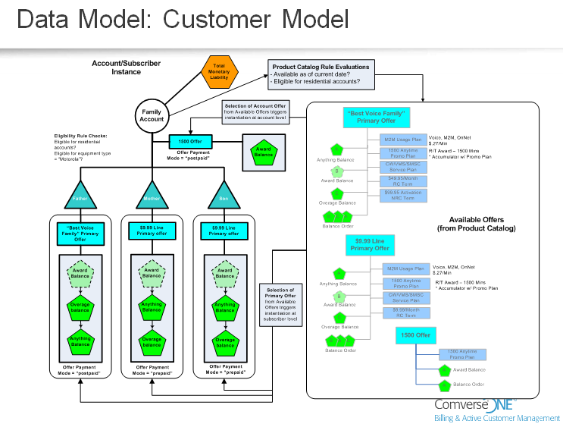

Figure 5: Data Model - Customer Model

### Account Hierarchy

As shown in the sample account hierarchy below, account hierarchies can be N levels deep and each tier can be N accounts wide. Accounts can have just one subscriber, many subscribers, or no subscribers, and each of them holds reference to the immediate parent and the root hierarchy account.

Account hierarchies can be used to reflect a customer’s organization structure, geography, departments, and so on. They can also be used to define which accounts will receive invoices and how some charges are redirected.

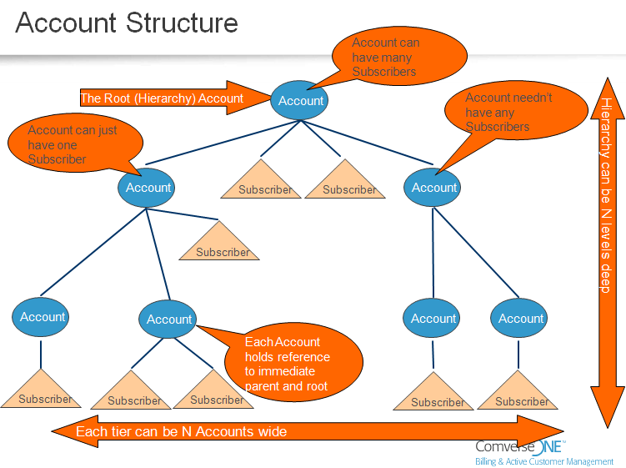

### Offers

An *item* is the most fundamental entity you can deliver to a customer. Types of items include usage, service, and provisioning. Items can be grouped into *plans*. Types of plans include usage, service, promotions, and inventory.

Plans can be grouped into *offers,* which in turn can be grouped into *bundles*. Offers can be primary, supplementary, or account type. Bundles are managed in the Customer database and the Billing database and can be at the account or subscriber level. Every subscriber bundle must have a primary offer. Every subscriber must have one (and only one) primary offer, either through a subscriber bundle or through a primary offer. An offer is the most granular object that can be delivered to an account or subscriber by a CSR. Offers can group plans, terms, balances, and accumulators. The solution supports primary, supplementary, and account offers.

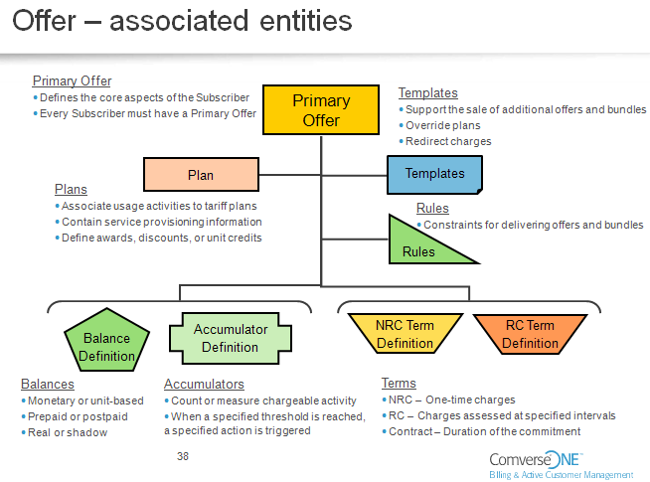

Figure 6: Offer - associated entities

### Offers & Payments

Each offer has a payment mode, which can be prepaid, postpaid, or hybrid. A hybrid offer contains one or more prepaid balances *and* one or more postpaid balances. In the above example, the father’s primary offer is postpaid and the mother’s and son’s primary offers are prepaid.

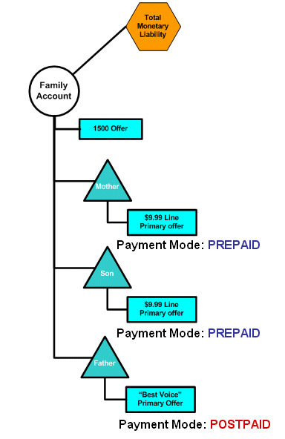 

Figure -- Offers & payment type

Both offers and bundles have their own set of criteria or *terms* for behavior. A term defines some pricing aspect of the agreement that is represented by the offer or bundle. Types of terms include recurring charge, non-recurring charge, and contract term (that is, the duration of the contract).

### Rules

Rule is used to check the pre-requisite for buying offers and bundles

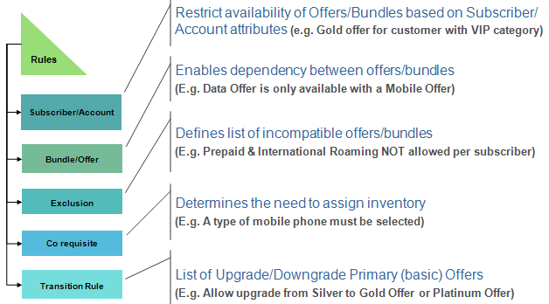

Figure – Rules

### Templates

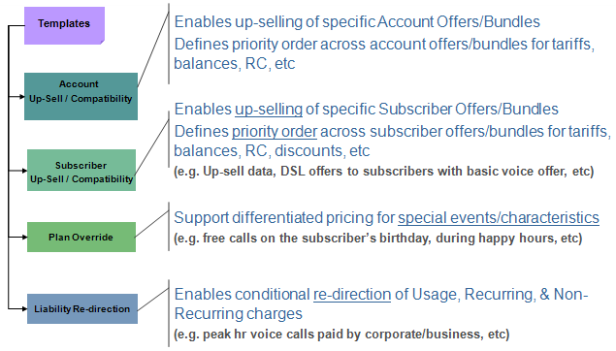

Figure – Templates

### Terms

Term information is handled as a text attribute on offer and bundle entities. You can define the following term types via the Product Catalog GUI:

* Recurring charge term (RC term)/ non-recurring charge term (NRC term)
* Contract Terms

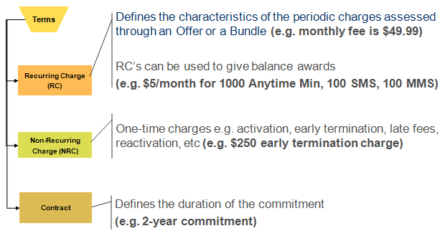

Figure – Terms

### Plans

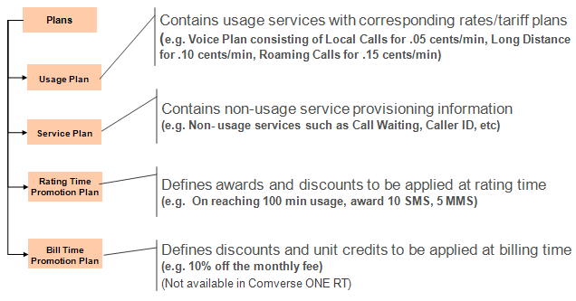

Figure – Plans

### Balances & Accumulators

Balances can be at the account or subscriber level and can represent real-time funds (monetary) or units (nonmonetary). Balance instances can be either prepaid or postpaid. While prepaid balances can hold funds or units and are decremented with each use, postpaid balances can hold limits or units.

Balance management capabilities include (1) eligibility of balances for particular services; (2) targeted promotions for specific balances; and (3) tracking the granting, consumption, and expiration of awards, bonuses, or notification triggers and so on.

#### Credit or Spending Limits

Postpaid monetary balances are cyclical and must have spending or credit limits. Postpaid nonmonetary balances are noncyclical and cannot have spending or credit limits. Postpaid running balances can be funded by increasing the amount of credit or spending limit. Credit limits are set by the operator to limit financial exposure. Only a Customer Service Representative (CSR) can change the credit limit. Spending limits are established by the customer to manage his or her own spending. Spending limits can be changed without special CSR authorization.

##### Credit limit sample cases

An operator who wishes to limit a subscriber’s monthly use of a balance can set a credit limit on that balance, as well as a cycle period and a reset date. The credit limit balances are tracked against the monthly amount to which the operator is willing to expose itself.

For example, if a customer has a $50.00 postpaid credit limit balance it means that the operator allows the customer to have up to $50.00 in charges in any given month. This credit limit is not affected by the customer’s payments or by any adjustments; it is simply a value established by the operator.

In this case if a customer has, for example, $20.00 in usage charges in a month, the current value of the customer’s postpaid credit limit balance is $30.00 (that is, $30.00 remaining from the original $50.00 credit limit balance). At the end of the month, the balance is reset back to $50.00, and the remaining $30.00 is not seen again because it does not represent an actual financial amount due to or owed by the customer.

The $20.00 in usage charges is reflected in the usage records that are generated on the Rating database and transferred to the Customer database over the month. These charges are invoiced by the Bill Invoice Process (BIP) and then the $20.00 is applied to the customer’s A/R balance, where it can be offset by any payments and adjustments.

Therefore, it is the usage charges that feed the A/R balance, via BIP. The postpaid credit limit balance on the Rating database is simply a type of “usage counter” used to deny authorization of real-time postpaid calls or to disconnect a call midstream if the credit limit is exhausted.

#### Total Monetary Liability

In addition, an operator can limit its financial exposure at the account level via Total Monetary Liability (TML). TML is a running total of how much money an account owes to a merchant (or anyone extending goods and/or services to an account).

The TML reflects all postpaid activities that accrue to the account; it reflects a combination of unbilled transactions plus billed and unpaid transactions. Various transactions can impact TML, including usage, recurring and non-recurring charges, payments, adjustments, and so on. Debits to the account (such as usage charges or purchases) increase the TML, while credits (such as payments or refunds) decrease the TML.

Associated with each TML is a TML Maximum, which is the maximum financial exposure (that is, credit) that the operator is willing to extend to the account.

Each account has its own running TML and TML Maximum, with the TML Maximum typically set based on the account’s credit-worthiness.

Note that TML is not a balance; it is a defined limit that can be used as part of the authorization criteria.

Setting a TML on an account is optional for operators. For example, operators often chose not to enforce TML on large corporate accounts.

#### Accumulators

Accounts and subscribers can have none or multiple accumulators. Accumulators track charges or events of a defined type and optionally trigger awards or promotions upon reaching a defined threshold. An account accumulator will accumulate events and charges at the account level, while a subscriber accumulator will accumulate charges and events at the individual subscriber level.

The figure below shows the relationship of balances and accumulators in a sample family account. Note that subscriber-level balances are used for charges incurred by that subscriber, while account-level balances can be used for charges incurred by that account, by subscribers associated to that account (see “”) or by other subscribers or accounts (see “”). Accounts do not have usage or usage plans, but accounts potentially have recurring/non-recurring charges, balances, and promotions plans.



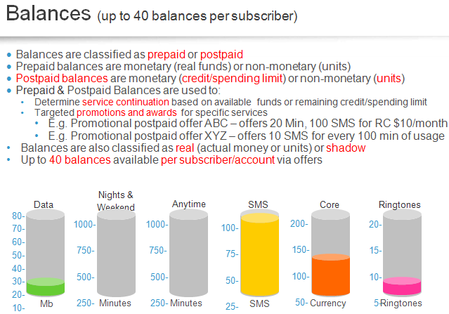

Figure 12: Balances

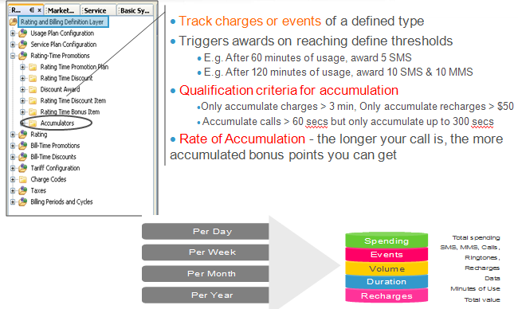

Figure – Accumulators

#### Charge Direction

There are two ways to support charge redirection using the solution: (1) shadow balances and (2) liability redirection.

#### Shadow Balances

Shadow balances are used for charge redirection from a specific balance to a different specific balance. A shadow balance (represented by the dotted-line pentagons in the figure below) can point to a real balance of any parent account in the same hierarchy. Balance-sharing rules define which subscriber shadow balances should be redirected to actual balances on an account level. CSRs can also set a limit on how much the shadow balances draw from the account-level balance. Shadow balances are cyclically reset.

The figure below shows the relationship of shadow balances in a sample family account. In the figure, the mother’s award consumption draws from the family account-level award balance. In this case, all award balances (for mother, son, and father) point to the award balances from the family account.



#### Liability Redirection

In addition to shadow balances, the solution supports the concept of liability redirection. Liability redirection is a way to redirect charges from an account or subscriber to another account or from an account or subscriber to a shadow subscriber on another account. Liability redirection can be pointer-based or shadow-subscriber-based.

Pointer-based liability redirection is used in situations where tariffs of the source entity are used to rate the call and the target account is paying for the charge. The CSR can set up the details of the redirection. For example, company XYZ might want its Finance department to pay for the invoices of its Sales and Operations departments.

Shadow-subscriber-based liability redirection is used to override usage charges by using the target subscriber’s rating plan. Internally, the original subscriber and the associated shadow subscriber have independent life cycles. The shadow subscriber has its own payment methods and primary offer/bundle and/or supplementary offers The CSR can set up the details of the redirection using Customer Center.

In the example shown in following figure, Acme pays for John Smith’s phone and voice service. But John also wants data service, even if he has to pay for it himself. When he requests this service, the CSR creates a shadow subscriber including the following (as represented in the far right column of the diagram below):

* John’s own account
* A shadow subscriber
* A data offer
* A data balance
* John’s own monetary balance



## Overview of the solution

The solution provides a very rich set of functionality to support all of an operator’s customer management and financial management needs. The functionality is grouped into the following five functional domains:

* Rating, Charging, and Promotions: Provides real-time authorization, notifications, online and offline rating, and comprehensive balance management
* Product Catalog
* Platform Management (Unified Platform Manager)
* Security
* Application Framework (Unified API)

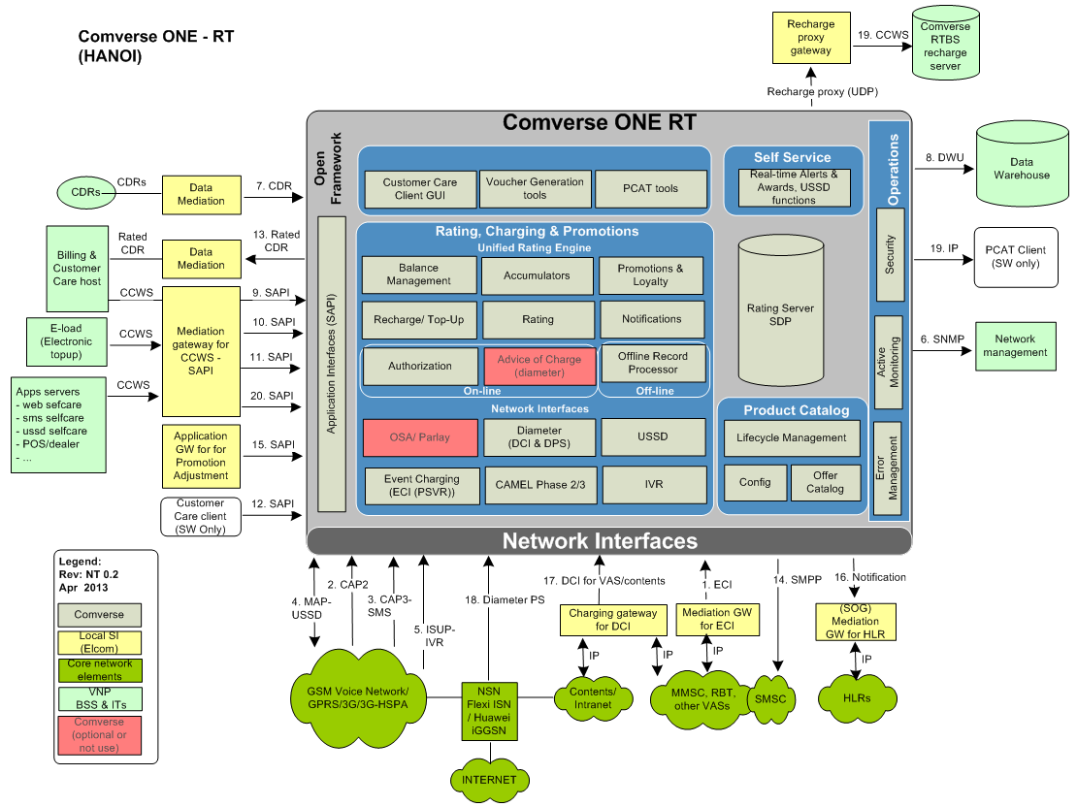

Please note that the following modules in Comverse ONE are different from RTBS

* PCAT (Product Catalog tool) versus SAW
* URP (Usage Record Processing)
* SAPI (Single API or Unified API) versus CCWS
* UPM (Unified Platform Manager) versus TRM

## Rating, Charging, and Promotions

The Rating, Charging, and Promotions domain covers the functionality involved in interacting with the customer via the operator’s network elements on a transactional basis. This includes real-time authorization and session control, pricing and charging a transaction, and providing for rating time promotions. Some of the key features of this domain include the following:

* Unified Rating Engine covering both online and offline processing
* Complete balance management for monetary and non monetary units irrespective of payment type
* Support for multiple technologies in a single platform

Comprehensive charge redirection models

* Real-time promotions that encourage usage and customer retention

## Product Catalog

Product Catalog is a single-point interface that manages all aspects of service provisioning in the solution. It allows quick and accurate creation and management of offers, bundles, plans, and terms. This can bring about dramatic reductions in operator product-development cycles. Product Catalog provides a holistic view of all relevant data and enables marketing-offer personalization and segmentation.

Not only does Product Catalog eliminate duplication of efforts, it also facilitates coherence and enhances lifecycle management and eases operational constraints. Due to its easy-to-use object-oriented interface, you can achieve faster turn-around time from product conception to market availability.

In addition, all prepaid and postpaid offers can be managed via a single interface, and multiple service categories (wire-line, mobile, cable, and so on) can be bundled together. Product Catalog also provides extensive capabilities for market segmentation, offer profiling, and inter-product rules. This allows operators to support brand and dealer offer segmentation. Data sets are versioned and are propagated in a coordinated manner.

Product Catalog supports evolution from prepaid or postpaid to converged, along with single service to multi-plays evolution. This centralized management of rating and billing definitions improves accuracy of configuration and reduces revenue leakage. Multilingual and multicurrency product, billing, rating, and charging definitions are supported.

Product Catalog interfaces are available for retrieving marketing offers and bundles and for loading basic rating and charging data.

One of the most salient attributes of Product Catalog is its use of logical layers. These logical layers are aimed at different user groups. For instance, the Marketing/Packaging layer is where the customer-facing market offers are configured, while the Service layer is where services and usage activities are defined. Other layers are the Rating and Billing Definition layer, and the Basic System Infrastructure layer.

Product Catalog enables coherent and flexible service provisioning in the solution via a single easy-to-use interface. It is organized into logical layers corresponding to different operational domains and user groups:

* Basic System Infrastructure Layer: For configuration of basic system data such as units and currencies
* Service Layer: For defining usage activities and service-related details such as notifications and access numbers
* Rating and Billing Definition Layer: For setting up rates, balances, accumulators, and promotions
* Marketing/Packaging Layer: For configuring customer-facing market offers

The figure below is a schematic view of the Product Catalog model and its organization within the GUI.

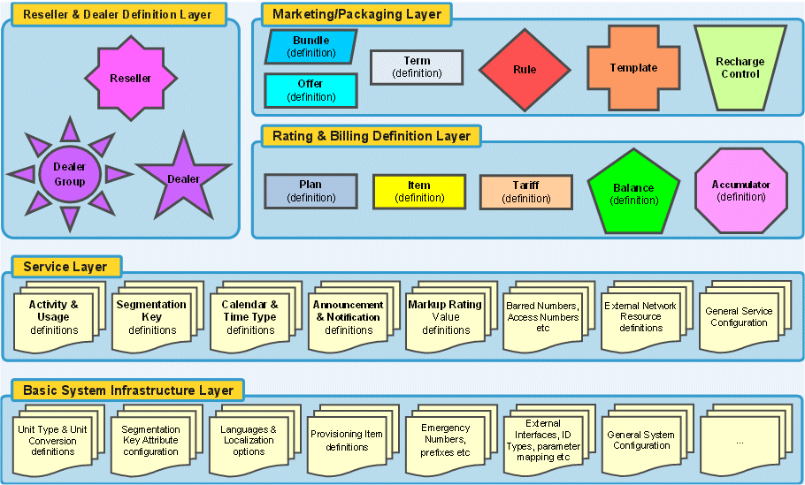

## Unified Platform Manager

The Unified Platform Manager provides a single centralized control point for all OA&M functions in the solution. This allows a single GUI and command-line interface (CLI) presentation to operate, administer, and maintain the entire solution system and to present the administrative capabilities such as process management and alarm notifications, for all units in the solution.

To support operations, the solution provides an interface for customers to operate the back-office applications (for example, Rating). This allows you to schedule and manage business processes. Scheduling solution system-wide activities (for example, backup procedures, jobs, workflows across the system, archiving activities) can be done centrally. The platform is oriented toward low-touch operations and helpful watchdog processes to monitor and restart continuously running processes (for example, Unified Rating Engine and database).

The following diagram shows the OAM perspectives of Unified Platform Manager



Figure -- UPM Architecture

## Security Server

**The solution provides security services that allow VNP to safeguard their data and enable users to do the work they need to do to maintain and use the system. Additionally, these capabilities can be used to achieve Sarbanes-Oxley compliance. The Security Server provides centralized authentication, authorization, and accounting to help achieve these ends.**

Security services are most easily remembered as AAA, for Authentication, Authorization, and Accounting. The solution provides excellent capabilities for all three of these areas.

**Authentication** is the ability to identify the intended user and to verify that the user requesting access is one of the users of the system. This authentication is provided through the exchange login and password security credentials. A robust password creation scheme allows administrators to set the terms and constraints of passwords to ensure that strong passwords are used. Functionality includes:

* Security Server authenticates and provides security assertions that are exchanged between applications
* All security assertions exchanged between applications are digitally signed
* Applications use the Security API to retrieve public keys that are managed by the Security Server
* Applications use the Security Server to authenticate the subject’s credentials

**Authorization** occurs when the system grants access and functionality privileges to authenticated users so they can do work. A system of roles and privileges allows administrators control of the user’s access to data and the capabilities to view and change the data. Functionality includes:

* GUI applications enforce Role-Based Access Control (RBAC) based on roles carried in the Security Assertion Markup Language (SAML) authentication statement
* The Unified API Server uses Extensible Access Control Markup Language (XACML) to enforce Policy-Based Access Control (PBAC)

**Accounting** is (1) the process of tracking the work that is occurring on the system and (2) the ability to associate any work back to a user. User actions are tracked by user activity records stored in logs, which allows any transaction to be traced to the user who performed the action if needed. The user activity records can be viewed centrally for the entire system. Functionality includes:

* The Unified API server and Unified Rating Engine use the Security API to construct and store user activity records locally
* The Operations Agent periodically transfers the user activity records from the local nodes to a central location
* Back-office users’ activity records are captured for all database transactions in the database
* GUI applications that use a middleware rely on the middleware to capture the GUI users’ activities
* GUI applications that directly use databases rely on the database to capture the GUI users’ activities

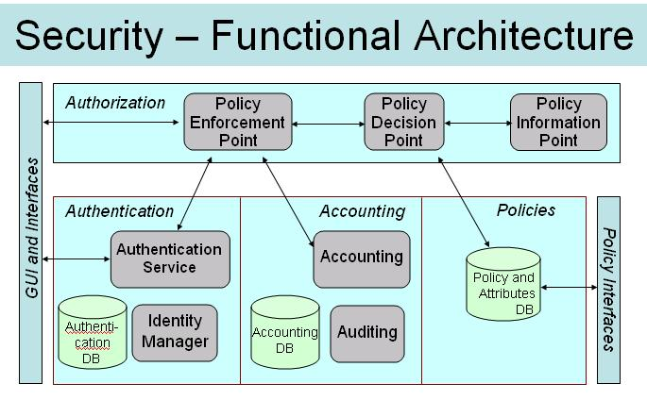

Figure -- Security functional architecture

## Unified API (Single API – SAPI)

The Unified Application Programming Interface (API) is a single framework that maintains full transactional integrity across the portfolio and is adaptive to deployment modes.

The Unified API includes the following functionality:

* Supports online transaction processing (OLTP) and batch deployment modes
* Supports Web Services as a standard interface
* The Unified API also includes an Enterprise JavaBeans (EJB) interface, but this interface is highly abstracted and is not intended for direct use by client applications that do not use the client SDK
* Exposes a set of objects and methods that expose a full breadth of integration functions of the Offer including customer care, balance management, and so on
* Supports virtual network operator (VNO) and dealer concepts
* Customizable by third parties via client software development kits (SDK)
* Provides the technical foundation necessary for your organization to pursue SARBOX compliance
* Supports multiple languages and localization (I18N and L10N)

The figure below is a high-level view of the Unified API.

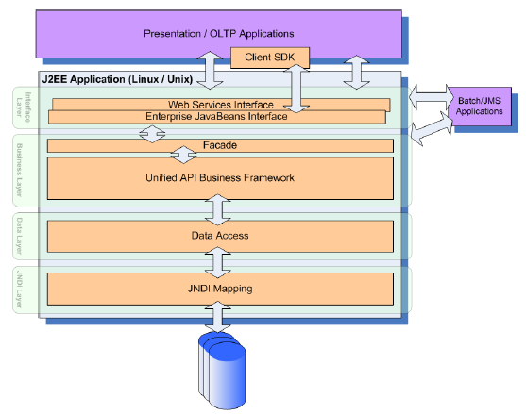

Figure -- UAPI Architecture

## Rating processing

The Unified Rating Engine (URE) is a single rating engine for all usage rating in the solution. The Solution Rating Library presents a single interface for any application performing any rating activity. The rating library is grouped in four modules:

* Guiding
* Pricing
* Charging
* Balance Management

These modules are hosted independently of each other and connect the rating libraries by functionality through a common URE API. The output of one, however, might serve as the input to another. Each module can contain one or more libraries. The Rating Library has the following functions:

* determines Segmentation Keys
* determines Final AUT
* determines Offer and Tariff information
* determines Discount and Bonus information
* determines Liable Party
* checks Service Eligibility

The following diagram shows the URE architecture

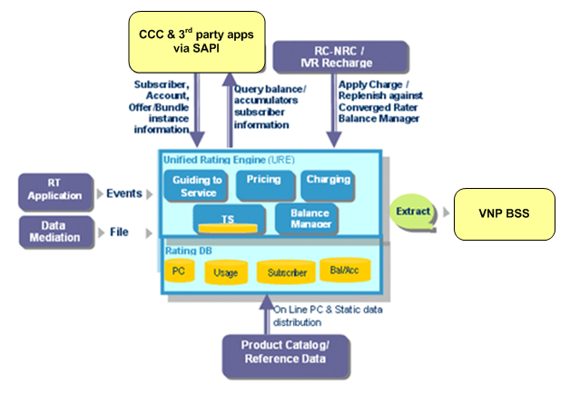

Figure -- URE Architecture

The real-time applications such as call processor, CAMEL 3 SMS/GPRS, Event Charging, OSA, and Diameter (Comverse SLE, Packet Switch, and IMS) provide input to the Unified Rating Engine in real time. The Unified Rating Engine is run in online mode to process usage events received via real-time applications. The figure below shows the processing of events via the Unified Rating Engine in online mode.

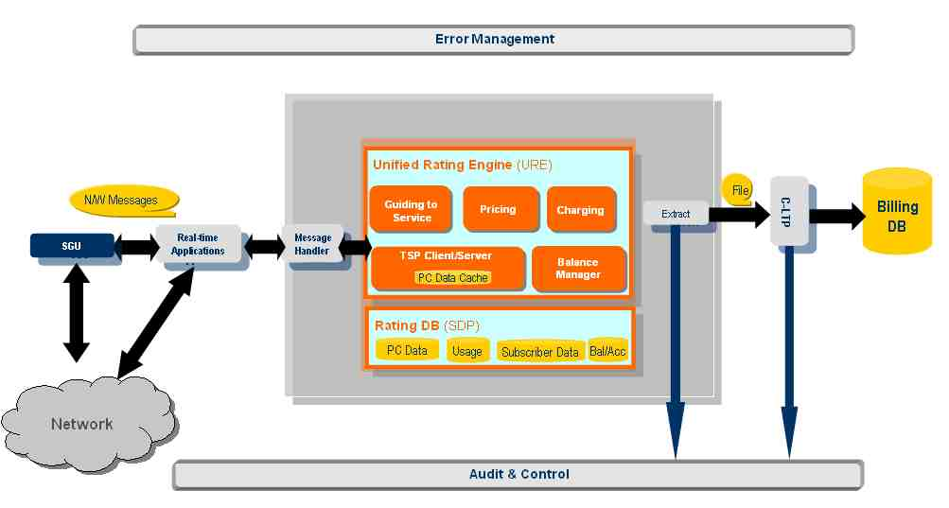

Figure -- Online URE

The Unified Rating Engine processes usage events received from Comverse Mediation via files in batch mode. The Unified Rating Engine is run in offline mode for processing the events received in batch mode. The Unified Rating Engine also processes the outage records in an offline mode. Outage records are internal and external records created during partial outages or temporary database unavailability for the purpose of revenue recovery. The figure below shows the processing of events via the Unified Rating Engine in offline mode.

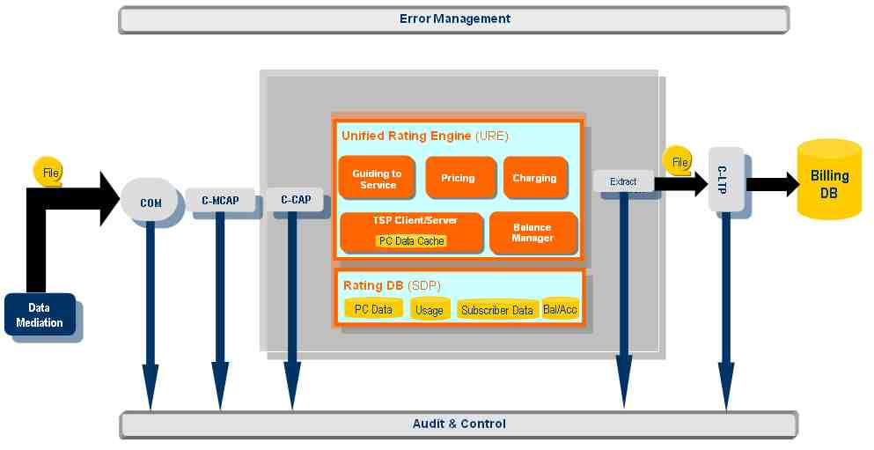

Figure -- Offline URE

## Re-Rating

Rerating is the ability to recalculate charges for previously rated or charged activities such as voice calls, data sessions, SMS, and so on. The following are possible reasons for re-rating:

* To comply with retroactive rate change, which may be caused by regulatory decisions
* To correct faulty configurations, which could include such things as the wrong tariff, wrong calendar, or wrong location setup
* To deal with CDRs received in a sequence that differs from the order in which the transaction occurred
* Billing period change
* Backdating a rate plan for a subscriber

Rerating selects unbilled usage and re-applies rates and pricing, re-guiding usage if necessary. The URC module collects unbilled usage data from such tables as CDR_DATA, sorting and packaging the data into files having C-CAP pick up and process those files and then call the URE to refund the original charge and apply new pricing to the usage.

The rerating process involves the following steps:

1. Trigger rerating by initiating a rerating request
2. Identify and collect records and pre-processing
3. Subscriber record and store rerating histories
4. Identify applicable service data and calculate the re-rated charges

Rerating is either basic or standard.

* Basic rerating -- Consider only directly affected records. Each record is re-rated individually with a delta recorded for each activity. The deltas of all affected records are tallied and the subscriber record is updated with the total.
* Standard rerating -- Consider all records for an individual subscriber within a period that includes all activities not directly affected.

In the solution the initial data comes from the CDR_DATA table. If in addition re-guiding is necessary, it may be necessary to apply usage to a different account or subscriber on a different database server than the original one.

### Rerating Criteria

Many scenarios can trigger rerating; as a result it is very difficult to determine which subscriber and transactions have been affected and must be re-rated. The following list describes as many scenarios as possible, but it is not and could not be a complete list.

* Retroactive Rate Change

Rates are retroactively changed mainly as the result of a regulatory decision. For example, a tax bill enforced by government requires application of a tax over the previous six months.

* Bad configuration

The scope of bad configuration could be very extensive. To name a few:

* Provisioning staff make mistakes in provisioning tariff. For example, a tariff in production reads $0.10/60Sec when it should be $0.09/60Sec.
* Provisioning staff make mistakes in provisioning calendar. For example, a tariff plan in production is associated with a wrong calendar or a calendar in production is associated with wrong time type (is off-peak when should be peak)
* Configuration files related to Location Resolution is wrong. For example, when supposed to use cell-id to resolve A-Location, a number is used instead.
* Subtype translation provisioning error. For example, a long-distance voice call subtype along with F&F special feature is translated to normal-long-distance-voice instead of F&F-long-distance-voice.
* Wrong paying parties identified because provision errors.
* Special feature discounts not applied because of wrong provisioning
* Bad configuration could happen anywhere in the system and any configuration parameters related to billing could make rerating being necessary.
* Rating Schema

Sometimes the rating schema itself might cause rerating to occur. For example, in the case of tiered rating, while a subscriber's usage is under 100 minutes, the rate might be 10 cents a minute, but when usage exceeds 100 minutes, the rate goes down be 9 cents a minute.

* CDRs out of order

When events are processed in the order in which URE receives them, rather than in the order of occurrence, promotional balances can be applied to wrong CDR.

* Billing period Change

Signing up for promotion or promotion plan changes during a billing period can make rerating necessary because the subscriber might accumulate enough usage to cross threshold for this billing period, or the accumulator may not have been set up.

Free units have been over consumed when billing period change/for the under consumed case, just reset free unit

* Backdating a rate plan for a subscriber

A CSR could back-date a subscriber’s rate plan because the service order placed by the subscriber was not processed in a timely fashion or CSR could back-date the rate plan for promotion purposes.

### Criteria for Identifying Subscribers and Transactions Affected

Since many scenarios can cause rerating, it is critical to identify which subscriber and what transaction rerating affects. Promotional balances, balance charge order, and account hierarchy make it more difficult to determine which subscribers/transactions are affected.

* Rerating one subscriber's activity can affect other subscribers in the same group; they share spending limit, for example; the same is true for any shared resources
* Rerating one subscriber's activities affects others who have a liability redirection relationship with the subscriber
* Rerating one subscriber's activities can affect other subscribers who share accumulators
* Rerating one transaction can affect any subsequent transactions even ones that do not directly relate to the transaction being re-rated
* Any monetary transactions such as recharge, recurring charge, refund, and the time when these happen can affect rerating result
* Any attribute related to rating changes in a subscriber record can affect rerating. For example, a subscriber who bought a la Cart service or changed class of service during the period when transactions needs to be re-rated.
* All accumulations must be re-processed. Any bonus/discount as the result of accumulation must also be re-calculated.
* Any group, F&F, VPN, and Calling Circle, related changes could affect rerating. In the online case, we do NOT know what his F&F at earlier point is. In offline, an operator can set up bonus and discount induced by special features to be retroactive, which would require re-rating.
* Expiration of balances and expiration of free units can affect rerating
* Any on-going activities after rerating request initiated may also need to be re-rated
* Offline rerating is restricted to unbilled call data, involving only a single bill cycle of data. However, by delaying bill generation or by backing out bills, it is possible to re-rate call records for multiple bill cycles. Online balances and accumulations are actively reset at the balance expiration or refresh/reset interval so rerating calls that were originally rated before the balance was reset would cause problems in the accumulations and potentially cause problems in the refreshed balances. Re-rating usage that affects online balances and accumulations that have been refresh/reset requires different handling of the rerating.

## Offline CDR Information

An offline CDR is a proprietary offline usage file that is an input to Comverse ONE, and is in the form of an ASCII file generated by the mediation device. It is a formatted file with a header that describes the format. Currently there are 40 record types for about 20 file types.

## ORP CDR Information

The Outage Record Processor (ORP) processes calls that may not have been rated at run time by a real-time process because the SDP was unavailable when the call occurred. Despite the Rating server being down, the subscriber can continue/complete the call. CDRs generated while an SDP is down are re-rated by the ORP. Call details during the outage are stored in the form of a CDR called the Outage Record. Outage Records are stored in the Outage Record file. ORP processes Outage Records, re-rates the call, and applies the appropriate charge for the activity.

Each Outage Record File consists of a file header followed by one or more outage records. The file header is 7 fixed-length fields. Each header field is null-terminated and consists of the ASCII representations of numbers, names, and so on. Data stored in these fields includes a checksum, file creation time stamp, and record count. The outage record comprises many variable-length fields, delimited by pipes, and containing ASCII representations of numbers, names, and so on. An empty field is indicated by two consecutive pipe delimiters (that is, '||'). Data stored in the fields include the usage activity's start and end date/time, a consumption amount, and an outage record processing result. Each outage record is terminated by a carriage return.

## Real Time CDR Information

The Rating Server generates real-time CDRs in the form of an ASCII text file that contains information in addition to that provided in usage files.

This information includes initial AUT, Tariff, and so on, as well as a lot of information that is also found in a usage file. Unlike the usage file, however, the CDR contains information about both completed and uncompleted calls. A completed call results in the creation of both a usage file and a CDR; an uncompleted call produces a CDR only. These records are created primarily for traffic analysis, although they can also be used in real-time deployments to feed downstream applications. Since they provide information about uncompleted calls, CDRs provide operators with a useful tool. Real-time CDRs are generated by the real-time applications (for example, by the Call Processor application) whenever a call ends (completed or uncompleted). The real-time application writes the CDR directly to the file system on the Rating Server where the application resides. These CDRs are subsequently picked up by an archival process and centrally stored on the UPM. Such files are generated on a service-level-configurable, periodic basis (as defined by the value of a service-level attribute). The default is one file every hour and the maximum frequency is one file every minute. The CDR types are listed in the following table

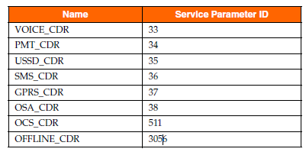

Figure : CDR service parameters

### Real Time CDR File name

The name of any billing file has the following format:

IPbill.<*cename*>.<*seq*>.<*nnnnnnnnnn*>

where:

<*cename*> is the host name of the SLU

<*seq*> is a 4-digit zero-filled sequence number from 0001 to 9999. The value of the sequence number is stored in the data/cename/IPbillseq file.

<*nnnnnnnnnn*> is a 10-digit representation of the coordinated universal time (UTC) in seconds (since 00:00:00 UTC, January 1, 1970. See time (2) when the file is open.

Example:

The active Billing Manager on slu1 opens the file named:

IPbill.slu1.0001.0000000000

if the system is started on 00:00:00 UTC, January 1, 1970.

### Real Time CDR file format

Each CDR file will contain a file header, followed by one or more CDRs. Each CDR has a CDR header.

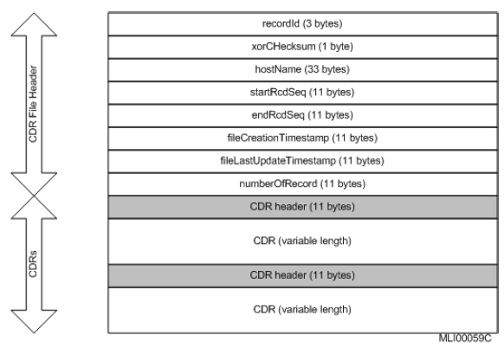

Figure : CDR header format

The CDR file has a dynamic set of Balances, Spending Limits, Accumulators and Extension information based on the subscriber’s configuration. The number of fields in a CDR record varies across the same type of activities, depending on the configuration specified in the format file.

### Real Time CDR Format configuration

The default format of a real-tme CDR is an ASCII, field-delimited record terminated by a newline character. A delimited CDR can vary in length as well as the fields contained within it. "|” is the default delimiter for a CDR field. The delimiter is configured in the CDRFormat.config file in the FIELD_DELIMITER field.

CDRs also contain sub-fields and sub-field delimiters. A sub-field delimiter is used within a field to separate each sub-field. "*" is the default sub-field delimiter for a CDR field. A subfield can also be configured to any ASCII character in CDRFormat configuration file in the SUB_FIELD_ DELIMITER field, which is different from FIELD_DELIMITER character.

The BALANCE_INFO, ACCUMULATOR_INFO, ACCOUNT_BALANCE_INFO, ACCOUNT_ACCUMULATOR_INFO, VERSION_INFO and EXTENSION_INFO fields are the six CDR fields that contain sub-fields.

## Rated CDR specification & Example

For more information, please refer to the following file



# System Preparation

The Solution can support

* RT postpaid rating/charging/promotion with
  + credit limit (same as prepaid today) – per Subscriber balance control
  + negative balance concept – per offer based balance control
* Different Reseller/Offer for RT postpaid will be needed
* Use either the concept of credit limit (similar to prepaid) or negative balances
* System will generate the rated CDR. It can be used by VNP Billing system for invoicing purpose
* System also support file based offline rating
  + for roaming user
  + postpaid subs which want to use the same rating/charging engine but does not want the system to monitor the call in real time
  + URP/ORP (Offline Record Processing) functionality will be needed. The URP/ORP does have specific data input format which VNP will need to prepare
* Need the trigger for RT postpaid subscribers (in HLR, same way with RT prepaid)

There are several impacts which will be needed the detail analysis from VNP as below

* Subscriber Migration –standard migration tools. It can be used for mass postpaid subscriber migration.
* Rerating functionalities are supported by solution. But some specific VNP re-rating which might not fully support by re-rating module shall be done in the existing platform. VNP does have external rerating functionalities outside the postpaid billing. It may possible to reuse
* Business Process/Operational process impact as below
  + Product configuration (PCAT versus existing postpaid config tool)
  + Offline rating process (Mediation function)
  + Rated CDR from Comverse system
  + SAPI API for RT postpaid subscriber inquiry
  + RT postpaid subscriber order/provisioning process
  + RT postpaid Subscriber life cycle

## High level System Configuration

There are several tasks which need to be done in order to configure the solution to support postpaid subscriber. This will be joint effort between VNP/Elcom/Comverse. The following are main activities

* System configuration for RT Postpaid subscriber such as network prefix, range map, and others
* Offers configuration for RT postpaid subscriber (Analysis information will be provided in the Section 5)
* Activity/Calendar/Tariff/Promotion/… configuration for RT postpaid
* URP/ORP configuration for file based transaction of postpaid subscriber
* Re-Rating criteria
* process for Rated CDR file transfer

## Subscriber Provisioning and Management

The CCWS (API) of Comverse RTBS will be replaced by SAPI. The SAPI will be used for prepaid/postpaid subscriber provisioning and management.

The CCC (GUI) can be used for postpaid subscriber provisioning and management. The special groups of CCC user with their own security set can be defined via the Security Server GUI.

## Offline CDR processing with Roaming

The roaming-subscriber originating/terminating voice-calls from non-CAMEL2 foreign networks will not be charged and controlled in real time. Vinaphone will get the roaming file from it roaming partners or clearing house. The mechanism by which operators exchange the billing information for roaming calls is the Transferred Account Procedure (TAP) record. TAP records provide the source of the activity usage that is to receive the markup. These records are collected by a clearinghouse and then transferred to the provider where the subscriber is billed.

To facilitate RTB billing, the postpaid system is responsible for reformatting the TAP records into the solution Offline CDR format, and sending them into the solution URE offline CDR file processing (URP) data stream.

This process includes:

* Collecting the TAP files from the clearinghouse(s)
* Reformatting these records into offline CDR format
* Feeding these records into the URE offline rating stream

The solution processes these records, provides the configured markup rating percentage, updates the subscriber’s real-time available balances (or credit limits), and creates the appropriate Activity History and CDR records.

# VNP postpaid working plan

The main purpose of the Real Time postpaid rating are

* Common real time rater for VNP subscriber. This will simplify VNP rating process. Solution as a single rater for both prepaid and postpaid will provide VNP with rating/charging convergence capabilities
* Full OCS (Online Charging System) capabilities for the VNP mobile network
* Provide VNP postpaid subscriber with on the shelf features which can be applied to postpaid subscriber such as multiple balanced, telescoping charging, usage based promotion, real time concurrent charging
* Use the solution credit control functionality to perform real time monitoring of postpaid subscriber
* Apply the real time promotion, bonus, notification, and others to improve the postpaid customer relationship will help VNP to reduce churn
* Maintain the system compatibility with existing VNP BSS environment

***Existing postpaid process***



***New postpaid process with Comverse Real Time postpaid***

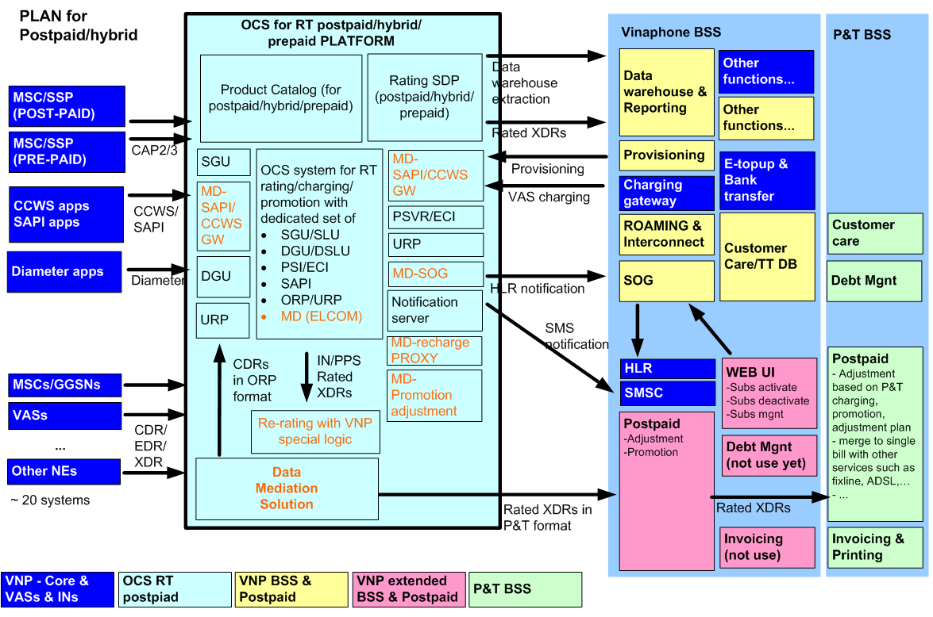

## Hardware & network readiness

. The system shall able to support additional postpaid subscribers with:

* Additional HW to support Unified Rating Engine and functions for postpaid real time charging.
* Additional HW for expand capacity if needed.
* Additional hardware for transition migration period.
* Software & configuration &service

Due to the postpaid subscriber and prepaid subscriber in VNP network shares the same prefix then the similar HLR IN-trigger setting of prepaid subscriber shall be applied for postpaid subscribers.

In solution, the postpaid subscribers will associate to special Offer (similar to COS (Class Of Services) in RTBS) which will be configured specially to support postpaid subscribers.

The Solution rates activities in real time for postpaid subscribers, the activities can be divided into 2 main categories, signaling base, and IP base.

* For Signaling based, the postpaid subscribers in this case are subscribers with IN-trigger. The network core (MSC) routes the IDP request (same as prepaid subscriber) to SGU in the solution’s system.
* For IP based, the postpaid subscribers will share the following components with prepaid subscribers -- SAPI, ECI(PSVR), Diameter OCS, IVR



## Working scope

|  |  |
| --- | --- |
| **No.** | **Activities** |
| 1 | Provide example of rated XDR information |
| 2 | Provide the CCWS documents to VNP BSS team |
| 3 | Prepare the system configuration (SP, COS, Range map (SDP allocation), and etc. Comverse will define the new SP/COS for postpaid subscribers |
| 4 | Prepare all service configurations based on the existing plan |
| 5 | Prepare the necessary re-rating capabilities |
| 6 | Prepare the data mediation capabilities |
| 7 | Prepare the process to perform the network trigger (IN) for OCS postpaid subscribers |
| 8 | Finalize the solution implementation such as credit limit (same as PPS logic) |
| 9 | Prepare the scripts which extract data from Postpaid and convert them to migration format |
| 10 | Finalize the migration strategy from existing postpaid system (platform by platform or big bang) |
| 11 | Prepare the Comverse migration script (use legacy migration script). We expect the date will be provided in our prefer format |
| 12 | Testing the migration scripts & migration process |
| 13 | Testing the system setting & migration scripts on the test system |
| 14 | Finalize the migration process (start from get data from VNP/Elcom) & all necessary sanity test |